**Foundations of Computer Science – Exercise 4**



1: Write contents of register D to bus 2 (DC2), read contents of bus 3 (DC3) to MAR, read contents of MM address given by MAR to MDR, write 1 to bus 1 (DC1), write contents of MPC to bus 2 (DC2).

2: Write contents of MDR to bus 1 (DC1), read contents of bus 3 (DC3) to register A, write 1 to bus 1 (DC1), write contents of MPC to bus 2 (DC2).

3: Write 1 to bus 1 (DC1), result of addition in bus 3 (DC3) is multiplied by 2, read contents of bus 3 (DC3) to register C, write 1 to bus 1 (DC1), write contents of MPC to bus 2 (DC2).

4: Write contents of register C to bus 2 (DC2), write 1 to bus 1 (DC1), read contents of bus 3 (DC3) to MAR, read contents of MM address given by MAR to MDR, write 1 to bus 1 (DC1), write contents of MPC to bus 2 (DC2).

5: Write contents of register A to bus 2 (DC2), write contents of MDR to bus 1 (DC1), c10 = read contents of bus 3 (DC3) to register B, write 1 to bus 1 (DC1), write contents of MPC to bus 2 (DC2).

1: 0+D -> MAR; MAR->MDR; 1+MPC -> MPC

2: MAR+0 -> A; ; 1+MPC -> MPC

3: (1+0)*2->C; ; 1+MPC -> MPC

4: 1+C->MAR; MAR->MDR; 1+MPC -> MPC

5: A+MDR -> B; ; 1+MPC ->MPC

It reads data of D to A, write 2 to C. Then add 1 to C and write to MDR. Write the sum of MDR and A to B. Therefore, B = D+3



0: 0+D-> A; ; 1+MPC -> MPC

1: 0+0-> B; ; 1+MPC -> MPC

2: ; ; (A = 0)+MPC -> MPC

3: ; ; 1000 -> MPC

4: 0+A -> MDR; ; 1+MPC -> MPC

5: MDR+B -> B; ; 1+MPC -> MPC

6: -1+A -> A; ; 1+MPC -> MPC

7: ; ; 10 -> MPC

8: 0+B -> A

|  |  |  |  |  |  |  |  |  |  |  |  |  |  |  |  |  |  |  |  |  |  |  |
| --- | --- | --- | --- | --- | --- | --- | --- | --- | --- | --- | --- | --- | --- | --- | --- | --- | --- | --- | --- | --- | --- | --- |
|  | 1 | 2 | 3 | 4 | 5 | 6 | 7 | 8 | 9 | 10 | 11 | 12 | 13 | 14 | 15 | 16 | 17 | 18 | 19 | 20 | 21 | 22 |
| 1 |  |  |  | 1 |  |  |  |  | 1 |  |  |  |  |  |  |  | 1 |  |  |  |  | 1 |
| 2 |  |  |  |  |  |  |  |  |  | 1 |  |  |  |  |  |  | 1 |  |  |  |  | 1 |
| 3 |  |  |  |  |  |  |  |  |  |  |  |  |  |  |  |  |  |  | 1 |  |  | 1 |
| 4 |  |  |  |  | 1 |  |  |  |  |  |  |  |  |  |  |  |  | 1 |  |  |  |  |
| 5 | 1 |  |  |  |  |  |  |  |  |  |  |  | 1 |  |  |  |  |  |  |  |  | 1 |
| 6 |  | 1 |  |  |  | 1 |  |  |  | 1 |  |  |  |  |  |  | 1 |  |  |  |  | 1 |
| 7 |  |  |  |  | 1 |  | 1 |  | 1 |  |  |  |  |  |  |  | 1 |  |  |  |  | 1 |
| 8 |  | 1 |  |  |  |  |  |  | 1 |  |  |  |  |  |  |  |  |  |  |  |  |  |



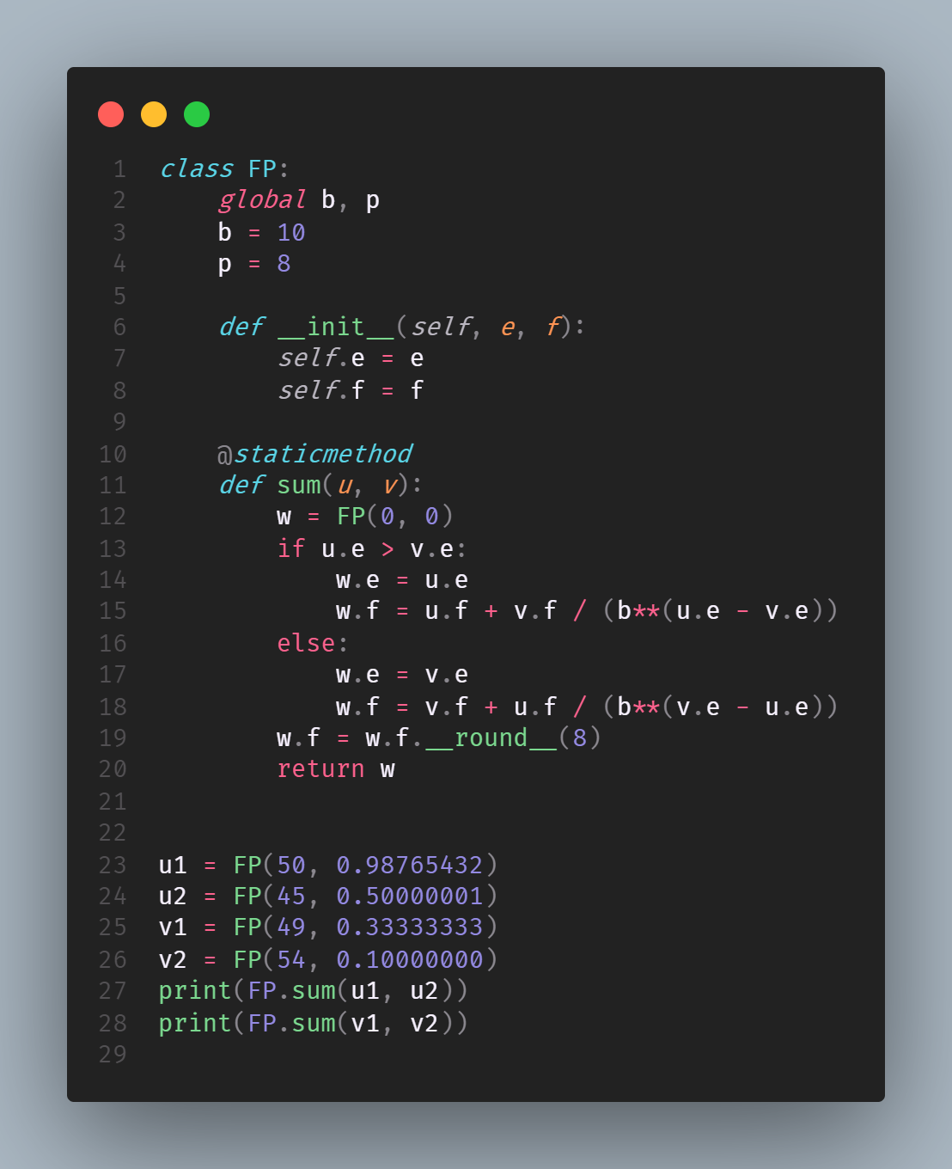

The workload will be more intense as floating points require more multiplication, division and comparison.



a) D = 0, MDR = 11, A=109

*First While loop:*

C = 11, 22, 44, 88

D = 1, 2, 3, 4

MDR = 22, 44, 88, 176

MDR = 88, C = 0

*Second While loop:*

D = 3, 2, 1, 0

C = (0, 1), 2, 4, (8,9)

A = (21, 42), 84, 168, 80

Final results: C = 9

b) D , which is how many times on the base of 2 dividend is bigger than divisor. The number of iterations would be the minimum correct integer answer of the in the following statement:

MDR >= A * 2D